LAB EXPERIMENT RECORD
Set 23: Employee Performance Analysis

Department | AIML
Course Code / Course Name | DSA0601 / Data Handling and Visualization
Experiment | Data Visualization using R and Tableau
Name | G. Ganga Chandrika
Register Number | 1925260144
Date | 17 October 2026
Day | Saturday

Aim
To visualize employee performance data using a bar chart, a line chart, a combined dashboard (bar chart and scatter plot), and a labelled performance table.
Dataset: Employee Performance
Employee ID | Department | Years of Service | Performance Score
1 | Sales | 5 | 85
2 | HR | 3 | 92
3 | Marketing | 7 | 78
4 | Sales | 4 | 90
5 | HR | 2 | 76

PROGRAM 1: Bar Chart of Employee Distribution by Department
Create a bar chart to visualize the distribution of employees across different departments. Label the chart elements.
# Create Employee Performance Dataset
employee <- data.frame(
Employee_ID = c(1, 2, 3, 4, 5),
Department = c("Sales", "HR", "Marketing", "Sales", "HR"),
Years_of_Service = c(5, 3, 7, 4, 2),
Performance_Score = c(85, 92, 78, 90, 76)
)
# Count employees in each department
department_count <- table(employee$Department)
# Create bar chart
barplot(department_count,
main = "Employee Distribution by Department",
xlab = "Department",
ylab = "Number of Employees",
col = "skyblue",
border = "black")
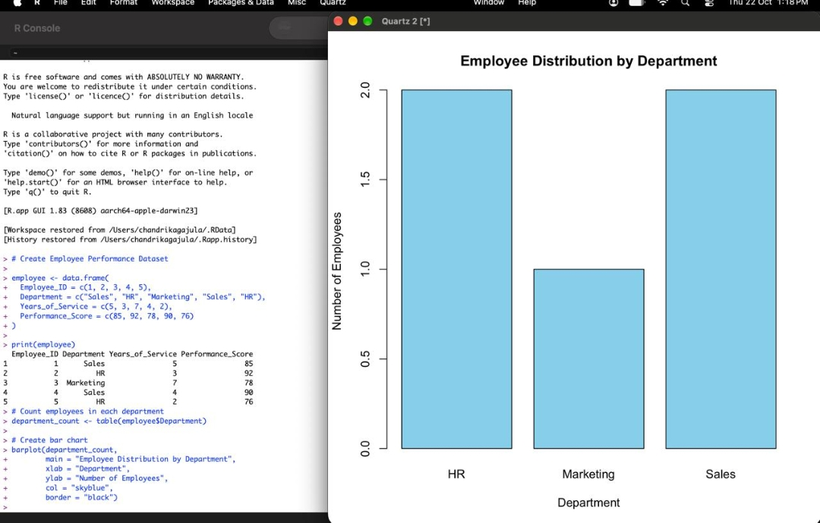
Output 1: Employee Distribution by Department Bar Chart
Observation: HR and Sales each have 2 employees, while Marketing has 1 employee, so Marketing is the smallest department.

PROGRAM 2: Line Chart of Employee Performance Trend
Generate a line chart to visualize the performance trend of employees over time. Label the axes and title the chart.
# Create line chart
plot(employee$Employee_ID,
employee$Performance_Score,
type = "o",
col = "blue",
pch = 16,
main = "Employee Performance Trend",
xlab = "Employee ID",
ylab = "Performance Score")
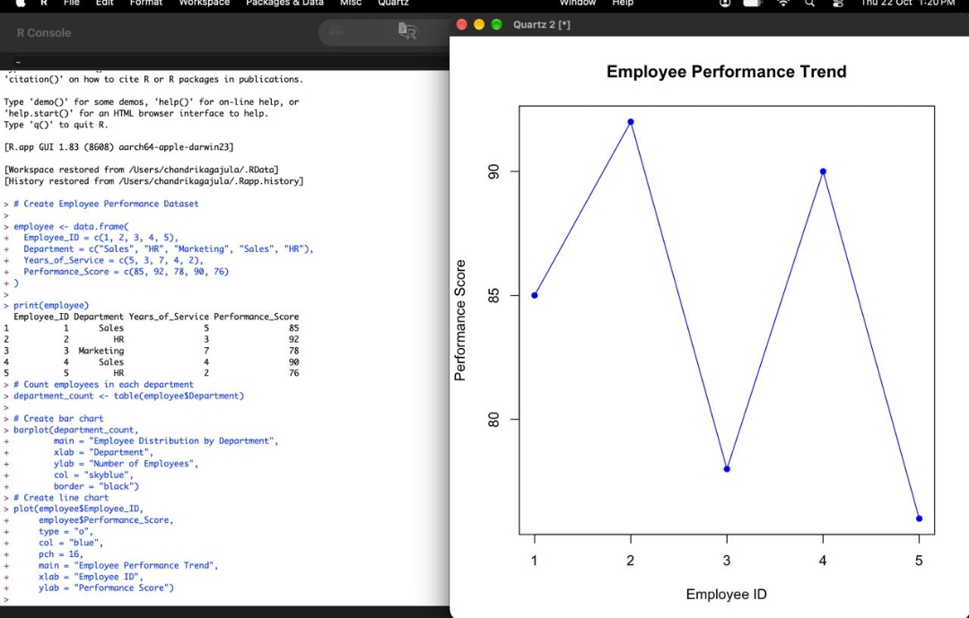
Output 2: Employee Performance Trend Line Chart
Observation: Performance rises from 85 to the highest score of 92 (Employee 2), falls to 78 (Employee 3), recovers to 90 (Employee 4), and drops to the lowest score of 76 (Employee 5).

PROGRAM 3: Employee Performance Analysis Dashboard
Build a dashboard combining a bar chart showing department distribution and a scatter plot displaying the relationship between years of service and performance scores.
# Set 23: Employee Performance Analysis
library(ggplot2)
library(gridExtra)
# Create the dataset
employee <- data.frame(
Employee_ID = c(1, 2, 3, 4, 5),
Department = c("Sales", "HR", "Marketing", "Sales", "HR"),
Years_of_Service = c(5, 3, 7, 4, 2),
Performance_Score = c(85, 92, 78, 90, 76)
)
# Chart 1: Department Distribution
p1 <- ggplot(employee, aes(x = Department)) +
geom_bar(fill = "skyblue", color = "black") +
labs(
title = "Department Distribution",
x = "Department",
y = "Number of Employees"
) +
theme_minimal()
# Chart 2: Years of Service vs Performance Score
p2 <- ggplot(employee,
aes(x = Years_of_Service,
y = Performance_Score)) +
geom_point(color = "red", size = 3) +
labs(
title = "Years of Service vs Performance",
x = "Years of Service",
y = "Performance Score"
) +
theme_minimal()
# Combine charts into one dashboard
grid.arrange(
p1, p2,
ncol = 2,
top = "Employee Performance Analysis Dashboard"
)
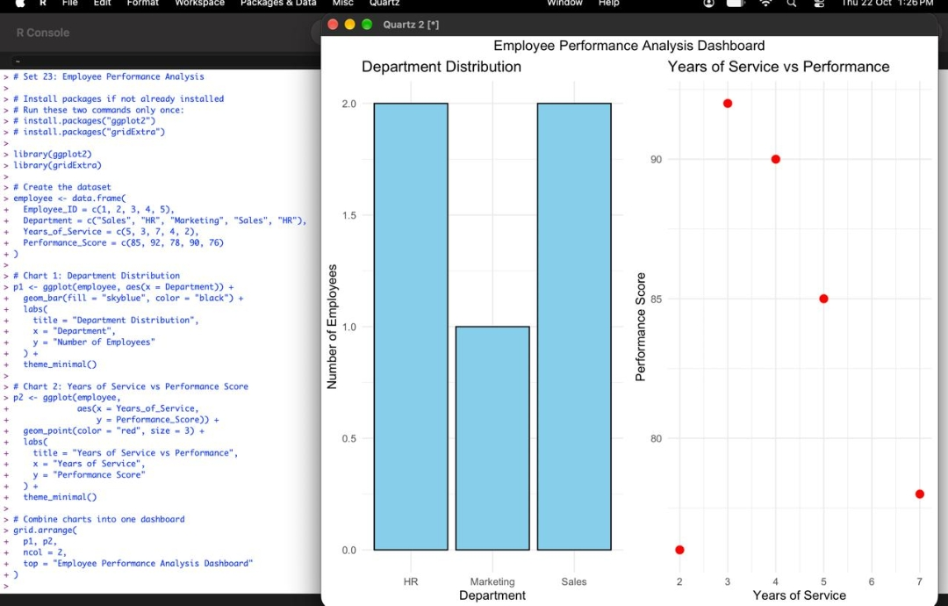
Output 3: Employee Performance Analysis Dashboard
Insight: The bar chart shows Sales and HR with 2 employees each and Marketing with 1. The scatter plot shows no steady increase in performance with years of service: the highest scores (92 and 90) occur at 3 and 4 years, while the employee with 7 years scored 78.

PROGRAM 4: Employee Performance Table
Develop a table showing the performance data for each employee. Label the table elements.
# Create employee performance table
performance_table <- data.frame(
Employee_ID = employee$Employee_ID,
Department = employee$Department,
Years_of_Service = employee$Years_of_Service,
Performance_Score = employee$Performance_Score
)
# Display table
print(performance_table,
row.names = FALSE)
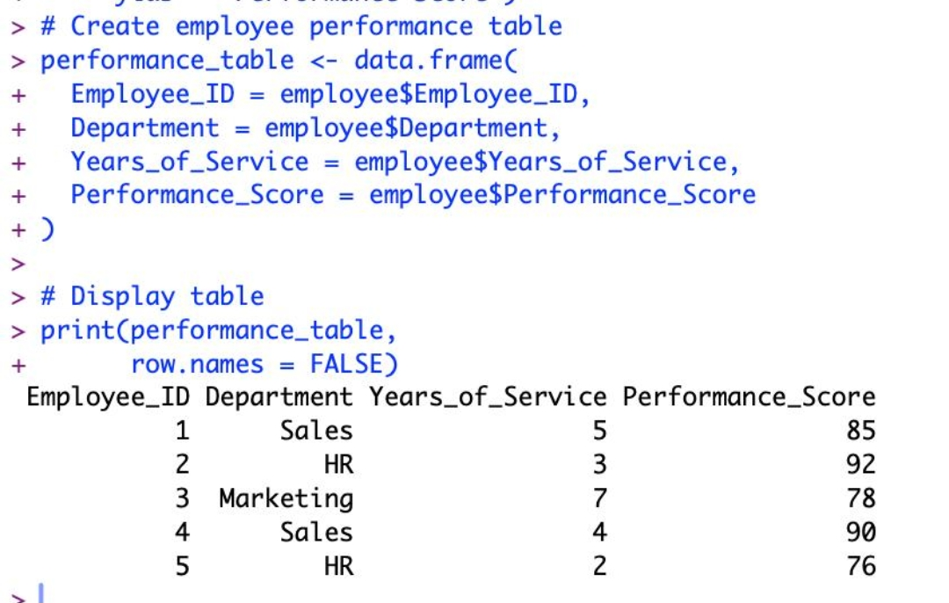
Output 4: Employee Performance Table
Observation: The table lists the Employee ID, Department, Years of Service and Performance Score of all five employees, with labelled columns.

Procedure
1. Create the employee data frame with Employee_ID, Department, Years_of_Service and Performance_Score.
2. Use table() to count employees in each department and barplot() to create the labelled bar chart.
3. Use plot() with type = "o" to create the line chart of performance scores with axis labels and a title.
4. Load ggplot2 and gridExtra, create the bar chart and scatter plot, and combine them using grid.arrange().
5. Create the performance table using data.frame().
6. Display the table using print() with row.names = FALSE.
Result
The employee performance data was successfully visualized using a bar chart, a line chart, and a dashboard combining a bar chart and scatter plot. The employee performance table was also displayed with labelled columns.
Key R Functions Used
Function | Purpose
data.frame() | Creates the employee dataset and performance table.
table() | Counts the number of employees in each department.
barplot() | Creates the department bar chart.
plot() | Creates the performance trend line chart.
ggplot() / geom_bar() / geom_point() | Build the dashboard bar chart and scatter plot.
grid.arrange() | Combines the charts into one dashboard.
print() | Displays the performance table.

